**User Story Map Template**

|  |  |
| --- | --- |
| Date | 9 November 2022 |
| Team Id | PNT2022TMID52122 |
| Project Name | Virtual Eye-Life Guard For Swimming Pools To Detect Active Drowning |

STEP-1

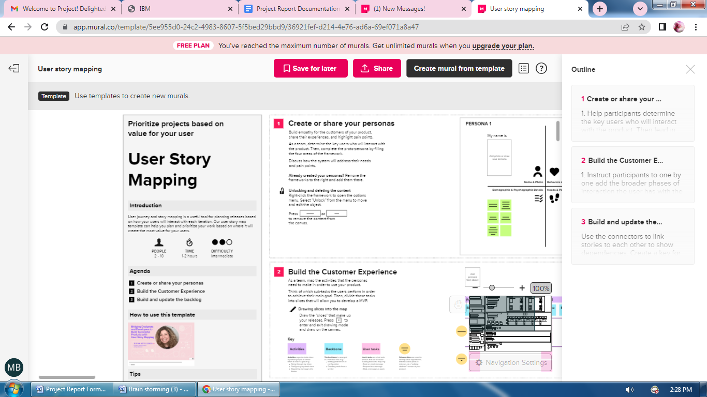

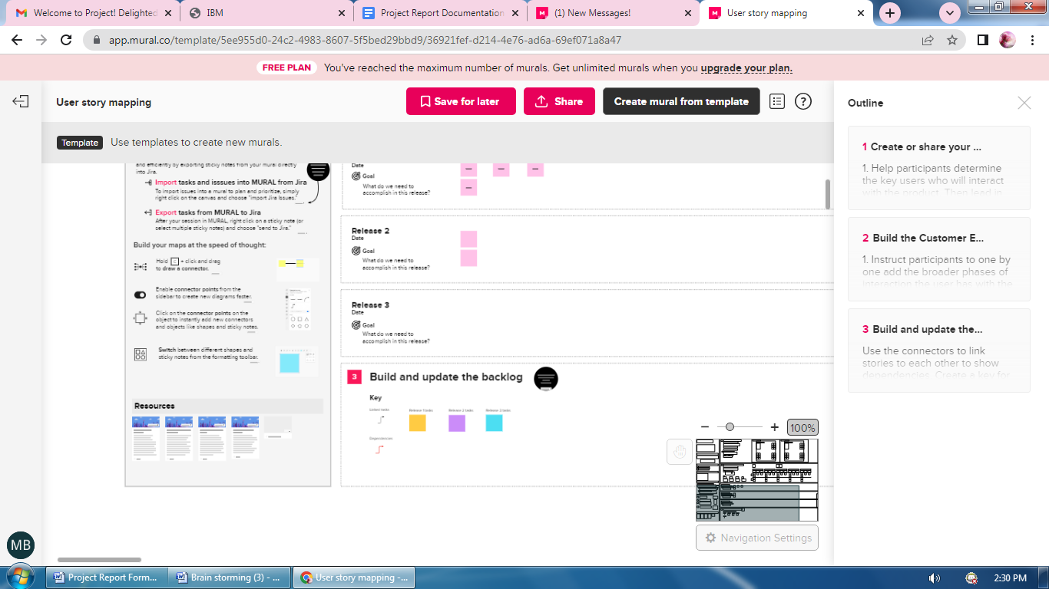

STEP-2

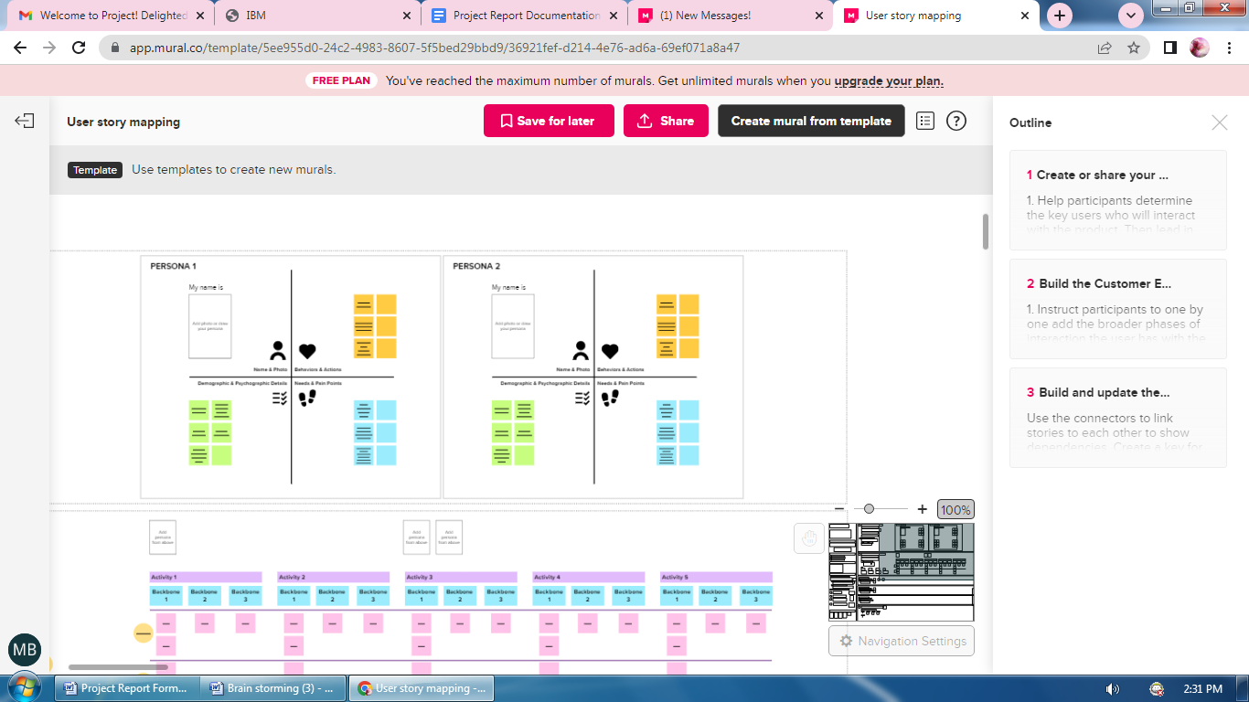

STEP-3